Dani has 16 apples.



Dani has some plates. She wants to put 2 apples on each plate.

Show how Dani groups the apples.

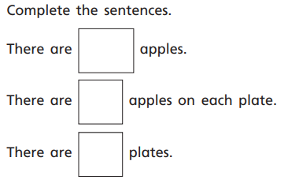

Sam has 20 chairs.

1. Circle groups of 4 chairs.
2. How many groups did you circle?
3. Can you create a number sentence that shows what you have circled?

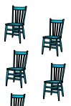

**True or false?**

