Dani has 16 apples.

Dani has some plates. She wants to put 2 apples on each plate.
Show how Dani groups the apples.

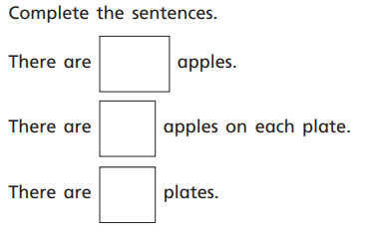

Sam has 20 chairs.
- Circle groups of 4 chairs.
- How many groups did you circle?
- Can you create a number sentence that shows what you have circled?
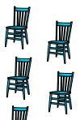

True or false?
