This strand explores the impact that technology has on health, well-being and lifestyle. It also includes understanding negative behaviours and issues amplified and sustained by online technologies and the strategies for dealing with them.

Your child should be able to identify rules that help keep people safe and healthy in and beyond the home when using technology and give some simple examples.

Discussion
Discuss with your child that there are a set of rules that children need to follow in order to be safe online, both at school and at home.
Ask your child what they already know about keeping safe online and offline.
- Children need to be supervised at all times when using technology.

- Children should ask for permission to use devices/the internet.

- They should always tell a trusted adult if they have seen something that they are unsure of, has upset them or has made them feel uncomfortable.

- Children should be taught not to talk to strangers online and offline.

- Children should be taught to never give away their personal information both online and offline.

Activity

- Create a poster to help promote online safety at home.

- Display their poster next to the online device as a visual reminder, when using the computer.
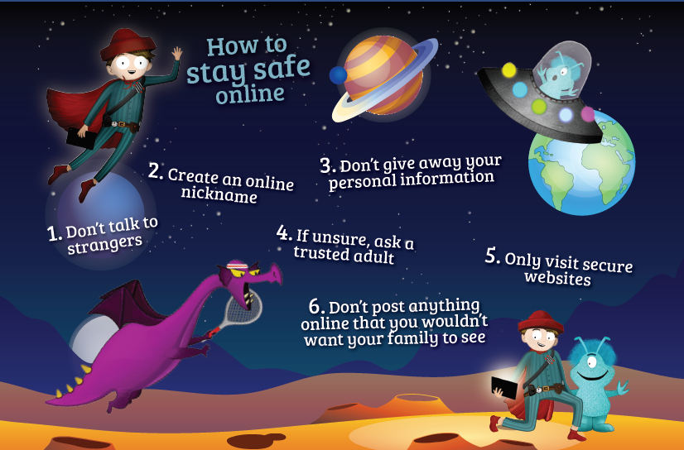

Activity 2

- Discuss the eight scenarios below. You need to sort them and decide which ones you use with a device, ex. For example, you would not use a device when at the cinema but you may use a device when at school for a learning task.

- Write ways in which you would or would not use their device for each scenario.

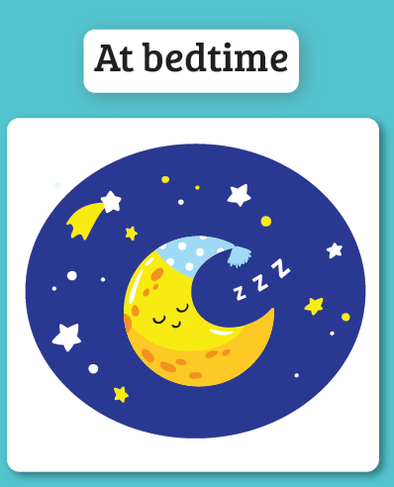
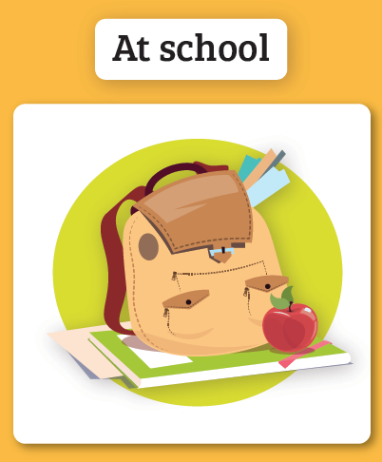
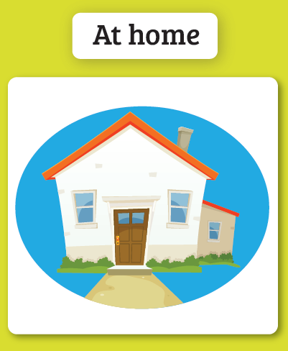

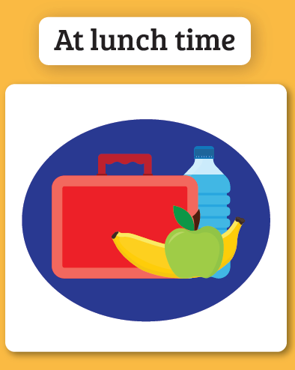
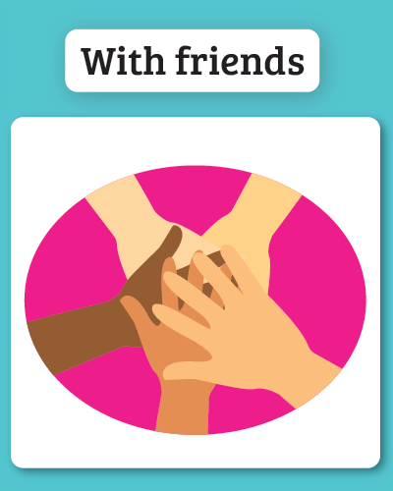
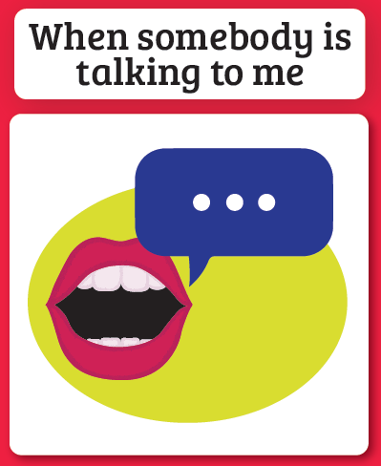

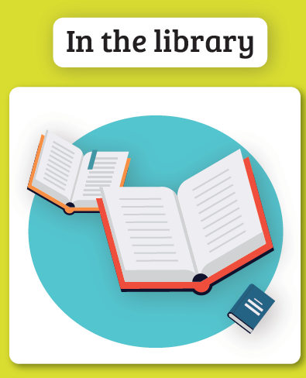

Extension Activity

- Think of other environments where you have to use your device in a certain way?

- Add them to your list.

