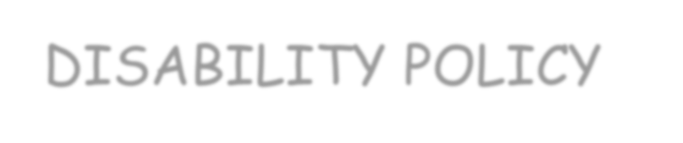
St Paul’s Church of England Academy
SPECIAL EDUCATION NEEDS AND DISABILITY POLICY



Staff Member and Governor responsible for the policy | SENCo & Governor
Date reviewed and shared with staff | November 2025
Date to be next reviewed by relevant staff | November 2026

Introduction

This policy outlines our approach to supporting pupils with Special Educational Needs and Disabilities (SEND) at St Paul’s CE Academy. It should be read alongside our SEND Information Report.

The policy and the practice reflected within it were development with input and feedback from all stakeholders, including pupils, parents/carers, staff and Governors.

At St Paul’s, we are committed to delivering high-quality education for pupils with SEND through high expectations, early intervention, and personalised support. This is achieved by consistently excellent teaching, effective use of resources, and a solution-focused, well-trained staff team working in partnership with families and professionals.

Our commitment to inclusion is rooted in our Christian values and our vision to be a beacon of light for all.

1. The Academy’s vision and ethos
At St Paul’s Church of England Primary Academy, our vision is to ignite a thirst for knowledge and learning, underpinned by a strong sense of belonging and inclusion.
Our Christian values—Persevere, Respect, Forgive, Honest, Serve, Thanks—are embedded in all aspects of Academy life. We aim to be a beacon for all, ensuring every child is valued and empowered to achieve their potential and thrive.

2. Definitions of SEND and our Inclusive ethos
SEND
Special Educational Needs and Disabilities (SEND) refers to children and young people who have learning difficulties or disabilities that require special educational provision. This includes those:
- who have significantly greater difficulty in learning than others of the same age; and/or
- who have a disability that impacts their ability to access mainstream education, as defined by the SEND Code of Practice (2014) and the Equality Act 2010.

The Code of Practice identifies four broad areas of need:
- Communication and Interaction, including speech, language and communication needs and Autism Spectrum Disorder;
- Cognition and Learning, covering a range of learning difficulties such as dyslexia and dyspraxia;
- Social, Emotional and Mental Health (SEMH), which may present as withdrawn behaviour, challenging conduct, or conditions like ADHD and attachment disorder; and
- Sensory and/or Physical Needs, including visual, hearing, multi-sensory impairments and physical disabilities.

We are equipped to support all commonly occurring SEND needs without requiring an Education, Health and Care Plan (EHCP), and can access training and external advice for more personalised needs.
Admission arrangements ensure no discrimination against pupils with SEND or disabilities, with decisions for those with EHCPs made by the Local Authority.

Inclusion
Inclusion is a core value at St. Paul’s and it shapes every aspect of our provision, curriculum, practice and relationships. Inclusion means ensuring equity over equality and giving each individual what they need to be the best they can be. This includes adapted provision, therapeutic support and a curriculum that reflects diversity and promotes belonging across the Academy.
We foster an inclusive culture where every pupil feels safe, valued and understood. Our approach is rooted in the belief that diversity actively enriches our community, and we celebrate differences in background, identity, talents and strengths.

Inclusive practice is embedded in all aspects of Academy life, from curriculum design to behaviour policy, and is supported by staff training and reflective practice. Examples of inclusion include flexible groupings, access to quiet and sensory spaces and the use of pupil voice to shape our provision. We work closely with families and external professionals to meet every child’s needs, viewing this at all times with an holistic and person-centred approach.

3. Roles and responsibilities
Leadership and management of SEND at St Paul’s is a whole-Academy responsibility, led strategically by the Governing Body, Co-Headteachers, SENCo and teaching staff. The Governing Body ensures statutory duties are met, including support for pupils with medical conditions, publication of the SEND Information Report, and compliance with the Equality Act 2010, while also working with senior leaders to shape SEND policy and provision.
The SENCo and Inclusion Lead, Mr Ian Smith, is a qualified teacher and member of the Senior Leadership Team, with day-to-day responsibility for coordinating SEND provision, supporting staff, and working with families and external agencies; he is also the Designated Teacher for Children who are Looked After, and a Deputy Safeguarding Officer. The Learning Support team at the Harbour includes Mrs Sally Webber (Behaviour Support Lead), Mrs Kim Morley (Designated Safeguarding Lead) and Mrs Lucy Saxby (Higher Level Teaching Assistant – HLTA).
Our staffing provision also includes in-class Teaching Assistants (TAs), Individual Needs Assistants (INAs), a Speech and Language Lead, and an English as an Additional Language (EAL) Lead. Co-Headteachers Mrs Maria Kiniari and Mr Tom Glenn are line managers for SEND, and class teachers remain responsible for the progress of all pupils, including those receiving additional support, using learning plans and Additional Needs Plans to plan, assess, and communicate provision in partnership with families.

4. Inclusive curriculum and adaptation
We set high expectations for all pupils, regardless of prior attainment, and use assessment to set ambitious targets. High-quality teaching, adapted to individual needs, is the foundation of our approach to supporting pupils with SEND, with additional interventions used to complement, not replace, effective classroom practice.
The Senior Leadership Team, including the SENCo, regularly reviews teaching quality, ensuring staff are equipped with strategies to identify and support vulnerable learners, in line with the SEND Code of Practice (2014, 6.37). Notional funding is used to support staffing for interventions and, where needed, to release teachers for targeted work.
Our curriculum is ambitious yet inclusive and accessible to all pupils. Lessons are planned to remove barriers to achievement and incorporate adaptations such as visual timetables, Widgit-supported visual vocabulary aids, differentiated tasks and personalised scaffolding. Teachers use sentence stems, chunked instructions, concrete resources, and multi-sensory approaches, alongside flexible seating and calm zones for emotional regulation.
Planning is guided by Universal Design for Learning principles, ensuring accessibility from the outset. Scaffolding strategies include pre-teaching vocabulary, visual prompts, and step-by-step modelling, while assistive technology—such as reading pens, tablets, and speech-to-text software—supports pupil independence.
At St. Paul’s, we prioritise the development of pupils’ emotional resilience and social skills through both direct teaching and everyday interactions with staff.
When concerns arise around SEMH, we apply the same systematic approach as we do for academic concerns, using targeted assessment tools to understand pupils’ needs and views. This enables us to provide appropriate support, which is further strengthened by the Learning Support team at the Harbour, including Mrs Sally Webber (Behaviour Support Lead) and Mrs Kim Morley (Designated Safeguarding Lead), reflecting our commitment to supporting SEMH alongside academic progress.
Collaborative learning is promoted through peer mentoring, mixed-ability group work, and structured talk activities, with formative assessment used to adapt teaching in real time. All pupils have access to a broad and balanced curriculum, with adaptations detailed in year group curriculum plans. Enrichment activities such as skateboarding, music, arts, and BMX are available to all pupils, who are also taught to ride a bike. Lunchtime clubs include art, dance, cookery, and sports, with participation tracked to ensure inclusive access.
Whether through reasonable adjustments for disabled pupils or special educational provision for those with SEND, we do whatever is necessary to help every child achieve the best possible outcomes.

5. Graduated approach
The Academy follows a robust Assess–Plan–Do–Review cycle, embedded across all phases to monitor and evaluate the effectiveness of support provided for pupils with SEND:
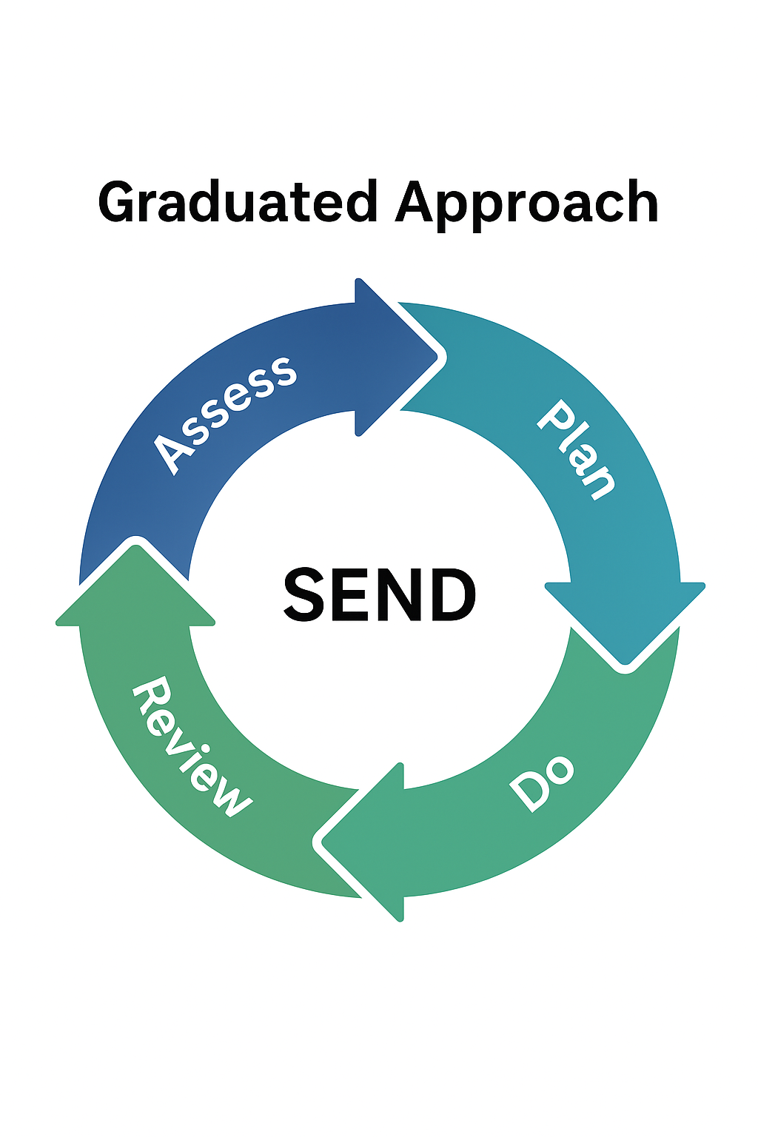
Evidence of progress is recorded with a focus on outcomes, using learning plans and Additional Needs Plans (ANPs), which are treated as working documents and updated regularly to reflect pupil voice and progress.
Pupil progress is monitored three times annually using provision management and tracking systems that evaluate the impact of interventions on academic and wider outcomes. Learning Plans are reviewed termly in line with assessment points, and ANPs are reviewed with pupils and parents three times a year, typically at the end of Terms 1, 3, and 5, with additional input gathered during Parents’ Evenings. Each review is informed by teacher assessments, pupil and parent views, and aims to refine support based on a growing understanding of the pupil’s needs.
For pupils with an Education, Health and Care Plan (EHCP), an annual review is held, attended by the SENCo, and includes an evaluation of the provision’s effectiveness, which is reported to the Governing Body. EHCPs are used to actively monitor progress toward outcomes and aspirations, and must be reviewed at least annually in partnership with pupils and parents.
Reviews consider whether outcomes and targets remain appropriate, and involve parents, Academy staff and a Local Authority officer. Prior to the meeting, all parties are notified and invited to contribute, with reports shared within two weeks.

6. Identification and assessment
SEND identification
A pupil is identified as having SEND when their learning difficulty or disability requires provision that is additional to or different from what is normally available to peers.
At St Paul’s, the identification of SEND is a thorough and inclusive process informed by a wide range of evidence, including developmental records, internal tracking via Insight, and regular pupil review meetings. Staff work closely with families and external agencies to ensure early recognition of needs, using pre-key stage assessments and personalised learning plans.

Assessment tools in use for each area of need include:
- Communication and Interaction: Speech Link, Language Link, NELI (Nuffield Early Language Intervention);
- Cognition and Learning: Sandwell Early Numeracy Test, YARC (York Assessment of Reading for Comprehension);
- Social, Emotional and Mental Health (SEMH): Thrive assessments, Boxall Profile; and
- Sensory and/or Physical Needs: Sensory checklists, Occupational Therapy screening tools.
Please note that the assessments in use at St. Paul’s are under constant review and this list is not exhaustive and is subject to change.

We recognise that any child may need extra support at some point, but this does not automatically mean they have SEND. Identification may arise from low attainment, limited progress, concerns raised by staff, parents, or the child, behavioural changes, or input from external agencies or previous settings.

On entry, pupils are assessed to establish baseline skills, and progress in core subjects is monitored termly. In EYFS, development in communication, physical, and personal-social areas is also assessed.
We use targeted assessments to identify pupils making less than expected progress, defined as significantly slower progress than peers, failure to match previous rates, or widening attainment gaps.
Academy responses to identified SEND
Initial responses focus on high-quality teaching and targeted interventions, which may include small group work or ICT-based support. Slow progress or low attainment alone does not confirm SEND, and conversely, age-appropriate attainment does not rule it out.
If a pupil continues to make inadequate progress despite targeted support, specialist assessments may be sought in consultation with parents. These help determine the resources and approaches needed, and if special educational provision is required, an Additional Needs Plan is initiated and shared with parents. Pupils who make sustained progress with this support remain identified as having SEND; if progress is maintained without it, the identification may be removed, with parents informed of any changes.
Where progress remains limited despite purposeful action, the Academy or parents may request an Education, Health and Care (EHC) needs assessment. The Local Authority considers evidence of support already provided before deciding whether to issue an EHC plan, which outlines provision across education, health, and social care, and sets short-term targets to support improved outcomes and preparation for adulthood.

7. Pupil and parent voice
Pupil views
Pupil voice is central to our inclusive ethos and person-centred planning. Pupils are actively involved in decisions about their learning, contributing to their Additional Needs Plans and Education, Health and Care Plans, and participating in wider Academy life through roles such as Academy Council representatives and Wellbeing Ambassadors.
We seek pupils’ views through strategies like pupil voice questionnaires, support them in setting short- and long-term goals, and provide age-appropriate information to enable meaningful participation in decision-making, with increasing independence encouraged as they grow older.
Parent/carer views

We are committed to working in close partnership with parents and carers to support pupils with SEND. We actively seek and respect their views, provide clear information to enable full participation in decision-making, and meet with them three times a year to review progress, alongside an annual written report.

Parents are engaged through workshops, informal conversations, meetings with key staff, and SENCo-led support with referrals, all aimed at helping their child achieve the best possible educational and developmental outcomes.

8. Provision for speakers of English as an Additional Language
Cultural diversity and equality of opportunity for all pupils is celebrated at St. Paul’s, whether pupils with English as an Additional Language (EAL) are at the early stages of language acquisition or are more advanced bilingual learners. We provide tailored support to enable equal access to both the curriculum and the wider life of the Academy community, recognising the importance of inclusive practice for pupils and their families.
Support includes a specialist EAL teaching assistant, help for parents with paperwork such as completing forms, and strong support to encourage integration and access to additional services. This holistic approach ensures that every EAL pupil is supported to thrive academically and socially.

9. In-house and external support routes
Support systems within the Academy
Safeguarding is overseen by Mrs Kim Morley (DSL), and Mr Smith and Mrs Webber are also part of the Academy’s Safeguarding team. This multi-disciplinary approach ensures that safeguarding is embedded across all areas of Academy life, with strong links to SEND and SEMH support.
The Academy offers a range of wellbeing services including counselling, therapy dog sessions, and the Wellbeing Ambassadors programme, which empowers pupils to support their peers and promote emotional resilience. These provisions are closely aligned with the work of the Learning Support team and reflect the Academy’s commitment to nurturing a safe, inclusive and emotionally supportive environment for all pupils.
Work with outside agencies

We work closely with external specialists when a pupil makes limited progress over time or continues to work significantly below age-related expectations, despite evidence-based support from trained staff. Parents are always involved in decisions to involve specialists, who may also be consulted early to advise on identification and effective interventions.

Together with families and agencies, we agree on the pupil’s needs, responsibilities, and desired outcomes, with clear review dates and records shared with all parties.

We collaborate with the Local Authority and commission services directly from trusted professionals familiar with our Academy, allowing for timely, tailored assessments and support.

This includes partnerships with CAMHS, MHST, CLASS, Eggtooth and others to support pupils’ academic progress and/or mental health and wellbeing. For children who are looked after by the Local Authority, we ensure close coordination with all professionals involved in their care.

10. Transition planning
We are committed to supporting pupils with SEND to develop the skills, confidence, and independence needed to thrive in adulthood, including employment, independent living, and active participation in their communities.
This begins with careful planning and preparation for transitions between educational phases, year groups, and settings, including bespoke support for Nursery to Reception, Early Years to Key Stage 1, and Key Stage 2 to secondary Academy.
Transitions are personalised using strategies such as social stories, transition booklets, and phased visits, with regular liaison between the SENCo and colleagues in previous and future settings to ensure continuity. We work closely with pupils’ previous educational settings to gather relevant information and ensure a smooth transfer, agreeing with parents and pupils on what will be shared.
Supporting pupils to build friendships and feel included in social groups is a key part of transition planning. This reflects the Academy’s vision of preparing pupils to become valued citizens of the world, with an emphasis on life skills, resilience and independence.
Our provision in the Lighthouse and wider therapeutic support play an integral role in helping pupils achieve these goals. The Lighthouse is the Harbour classroom where the HLTA, Mrs Saxby, and an INA support groups of carefully identified pupils in small groups, focussing on developing emotional regulation to prepare for the classroom. Pupils receive support to transition between activities and to build learning habits around phonics, writing and maths in a safe and settled environment. Pupils will then apply the skills and adherence to routines which they have used in their Lighthouse sessions in their whole-class time.

11. Monitoring, evaluation and review
SEND provision is monitored through Insight tracking, governor reports, peer reviews, and SEND audits. The SENCo works closely with colleagues in partner Academys to share and embed best practice between Academies.

Within St. Paul’s, weekly CHOC (Child of Concern) meetings support strategic oversight, and the SENCo and DSL are part of the Academy’s Senior Leadership Team which meets weekly. This policy and the SEN Information Report are reviewed annually by the SENCo and Headteachers.

12. Accessibility and equality
St. Paul’s provide physical adaptations including ramps and sensory spaces. Each year group has access to at least one ground floor classroom. The Harbour is a single-floor space which is fully accessible.

Alternative communication formats are embedded within the classroom, including large print text, Widget symbols and translated materials as appropriate. The curriculum is also audited to ensure diversity, equality and inclusion has been considered in all areas.

13. Staff development
The quality of teaching for all pupils, especially those with SEND and those at risk of underachievement, is regularly and rigorously reviewed by the Senior Leadership Team, including the SENCo. This includes improving staff understanding of strategies to identify and support vulnerable learners, and ensuring that interventions are delivered effectively by staff with the appropriate skills and knowledge.
The progress of pupils with SEND is a core part of the Academy’s performance management and professional development strategy, with staff expected to engage in ongoing CPD to deepen their understanding of a wide range of needs.
Staff receive training on inclusive pedagogy and specific areas such as literacy, numeracy, Autism Spectrum Disorder (ASD), Attention Deficit Hyperactivity Disorder (ADHD), Social, Emotional and Mental Health (SEMH), and trauma-informed practice, aligned with evolving pupil needs.
The SENCo coordinates a wide range of individual and whole-Academy training opportunities and courses to stay up to date with best practice. Notional SEND funding is used to support staff training, ensuring that professional development is matched to Academy priorities and equips staff to meet the diverse needs of learners.

14. Funding for SEND
St Paul’s Academy allocates a portion of its overall budget, known as the notional SEND budget, to support and improve outcomes for pupils with special educational needs and disabilities. Although not ring-fenced, this funding is used strategically to purchase resources, train staff, pay the salaries of class-based and non-class-based Inclusion staff, and commission specialist assessments. The focus is on ensuring that pupils receive high-quality support tailored to their individual needs.
Where the cost of provision for a pupil exceeds the nationally prescribed threshold, the Academy can apply to the Local Authority to be provided additional top-up funding. This ensures that pupils with more complex needs can access the specialist support required to help them thrive academically, socially and emotionally.

15. Data protection
Learning Plans, Additional Needs Plans, EHCPs and other SEND documentation are stored securely to ensure confidentiality and prevent unauthorised access. These documents are only shared with parental consent, except where disclosure is necessary for specific educational or safeguarding purposes or in the best interests of the pupil.
For further details on how pupil information is managed and protected, please refer to the Academy’s Data Protection Policy.

16. Complaints and dispute resolution
Concerns are addressed through an open-door culture and early dialogue, with the SENCo providing transparent support throughout referral processes.
We prioritise resolution through collaboration and mutual respect, and if disagreements arise regarding a child’s support, we work closely with parents to resolve them.

Should parents/carers wish to make a formal complaint, the Academy’s complaints procedure can be followed, which is available from the Academy office or on our website: www.stpaulsceAcademy.org.
For further statutory guidance, please refer to the SEND Code of Practice (2015): https://www.gov.uk/government/publications/send-code-of-practice-0-to-25

